Naan Berenji ~ Persian Rice Cookies

*by*MY PERSIAN KITCHEN*on MARCH 7, 2011*

[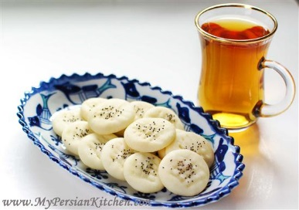](http://mypersiankitchen.com/wp-content/uploads/2011/03/Naan-Beremji1-Custom.jpg)

Baking cookies is a big part of the days leading up to the Persian New Year. I am really excited to share this recipe with you for a couple of reasons. One because Naan Berenji is one of my favorite Norouz cookies, but also because of the person who gave me this recipe.  This cookie is really simple to make and this recipes make a lot of cookies. Not only is it easy, it’s also gluten free and dairy free!

I have included the converted amounts into cups for those of you who don’t have a scale!

[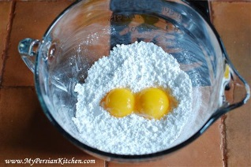](http://mypersiankitchen.com/wp-content/uploads/2011/03/Naan-Beremji2-Custom.jpg)Ingredients

500g rice flour  
200g confectioner sugar  
250g oil  
1/2 cup rose water  
2 eggs  
poppy seeds

Separate eggs and set egg whites aside.  In a bowl place confectioner sugar and egg yolks.  I would suggest sifting your sugar.

Add oil to sugar and yolks and mix well.

[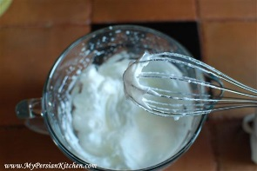](http://mypersiankitchen.com/wp-content/uploads/2011/03/Naan-Beremji4-Custom.jpg)Beat egg white in another bowl until firm.

[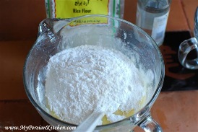](http://mypersiankitchen.com/wp-content/uploads/2011/03/Naan-Beremji5-Custom.jpg)Add rose water and rice flour to the eggs, sugar and oil.

[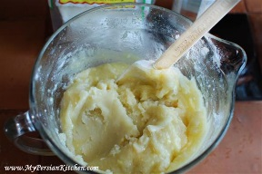](http://mypersiankitchen.com/wp-content/uploads/2011/03/Naan-Beremji6-Custom.jpg)

[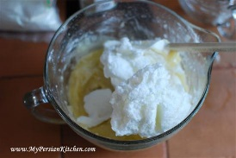](http://mypersiankitchen.com/wp-content/uploads/2011/03/Naan-Beremji7-Custom.jpg)Mix well.

[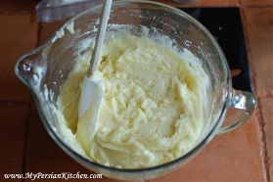](http://mypersiankitchen.com/wp-content/uploads/2011/03/Naan-Beremji8-Custom.jpg)Fold in the egg whites.

[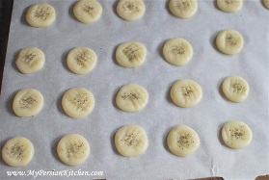](http://mypersiankitchen.com/wp-content/uploads/2011/03/Naan-Beremji9-Custom.jpg)Mix well. Let the dough rest overnight in the fridge.

I found that the best way to make these cookies was to shape them into a small ball the size of a hazelnut. Please them on a cookie sheet lined with parchment paper. The gently press them down into a round form.  Then take a fork and create indentations on each cookie. It is best to do this when the dough is nice and cold so that the fork doesn’t stick to the dough.  Then sprinkle some poppy seeds on each cookie and bake for 25 minutes in a 300º oven.